CAPSTONE PROJECT
PW25_SSS_06

Generative AI in marketing

Documentation of work progress and action items-

Recap of status till Phase2 completion-
- Prompt generation based on user input and then its enhancement-Mistral
- Background generation using prompt as input-Stable diffusion
- Product placement in the generation background .
  - Logic- Detect empty spaces in the generated background image and place the object there.
- Text placement using coordinates-bottom,top etc.

Phase 3-
1.Scope and domain of products that will be explored-
Product Categories
- Watches
- Perfumes
- Jewelry
- Cosmetics
- Electronics
- Premium Accessories
- Footwear
- Skincare
- Designer Bags
- Home Décor Items
- Luxury Beverages
- Tech Gadgets
Target Audience
- Age: 20–45 years
- Gender: All genders
- Income Level: Middle to high-income groups
- Location: Urban and metropolitan regions globally
- Behavior: Brand-conscious, trend-oriented, tech-savvy, and quality-focused shoppers

2. Progress made in phase 3
- Enhancement of background generation.
  - Creating more optimized background that work more efficiently in the Ad domain.
Generate a solid colour and pattern background constrained by user input
Generate a stand/pedestal where the product image can be inlaid
- Inlaying product image on the identified surface using surface detection techniques

Evolution of ads generated in the phases-
1)
a.Product image manually placed by explicitly providing coordinates.
b. Background generation thru manual prompt -Random ,not efficient.

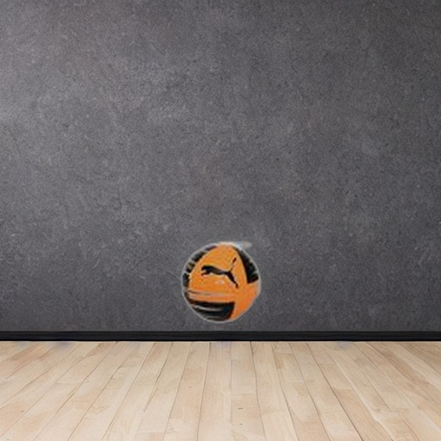

2)

- Background generated from prompt engineering, but not very ad friendly
- Product placement random

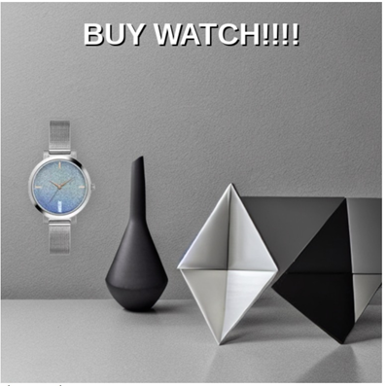

3)
- Trying to generate bg of the below type with explicit surface/stands for display.
- Product smartly placed on the identified surface- Highlights product that is being advertised.


Tasks yet to be completed-
- Complete integration of pipeline.
- Adding more relevant text appropriately.
- Creating UI for the process
- Testing

